**Practical 1**

Q1) In an online shopping website, Guest user gets a 15% discount on all their purchases today. For an existing customer no discount is given. If the user has a gift card, they get 20% off today (but it can’t be used with the ‘guest’ discount). Display appropriate messages on the final discount %

Perform the following

1. Write a html code and save in xampp/htdocs/prac1.html

2. Write a php code save in xampp/htdocs/prac1.php

**HTML Code:**

<html>

<head>

<title>

Testing Practical - 1

</title>

<body>

<form action="prac1.php" method="POST">

Enter the type of User :

<select name="user">

<option value="0">--Select User--</option>

<option value="1">Guest</option>

<option value="2">Customer</option>

</select>

<br>

<br>

Do you have Gift Card ?

<select name="gift">

<option value="0">--Select--</option>

<option value="1">Yes</option>

<option value="2">No</option>

</select>

<br>

<br>

<input type = "submit" value="Submit Form">

</form>

</body>

</html>

**PHP Code**

<?php

$user=$_POST["user"];

$gift=$_POST["gift"];

if(($user=="0")||($gift=="0"))

{

echo "Invalid Data";

}

if($user=="1")

{

if($gift=="1")

{

echo "You are eligible for 20% discount";

}

if($gift=="2")

{

echo "You are eligible for 15% discount";

}

}

if($user=="2")

{

if($gift=="1")

{

echo "You are eligible for 20% discount";

}

if($gift=="2")

{

echo "You are not eligible for any discount";

}

}

?>

**Using Selenium IDE, Write a test suite containing minimum 4 test cases.**

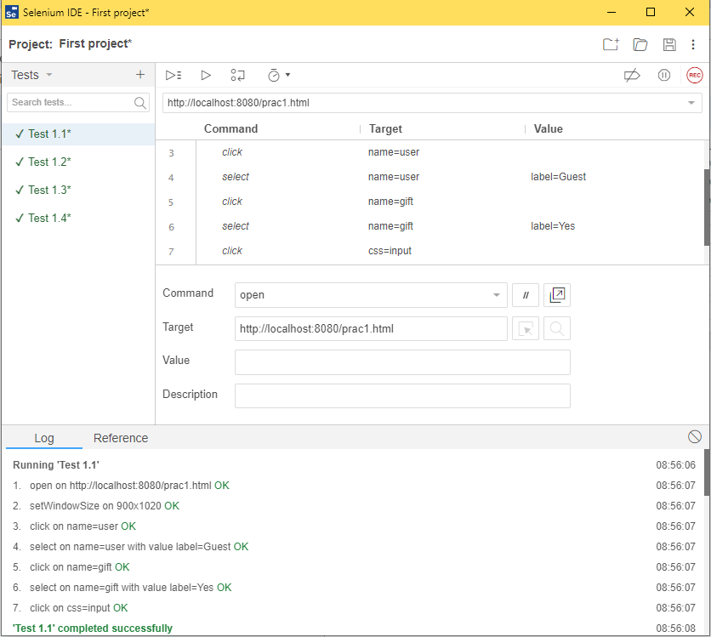

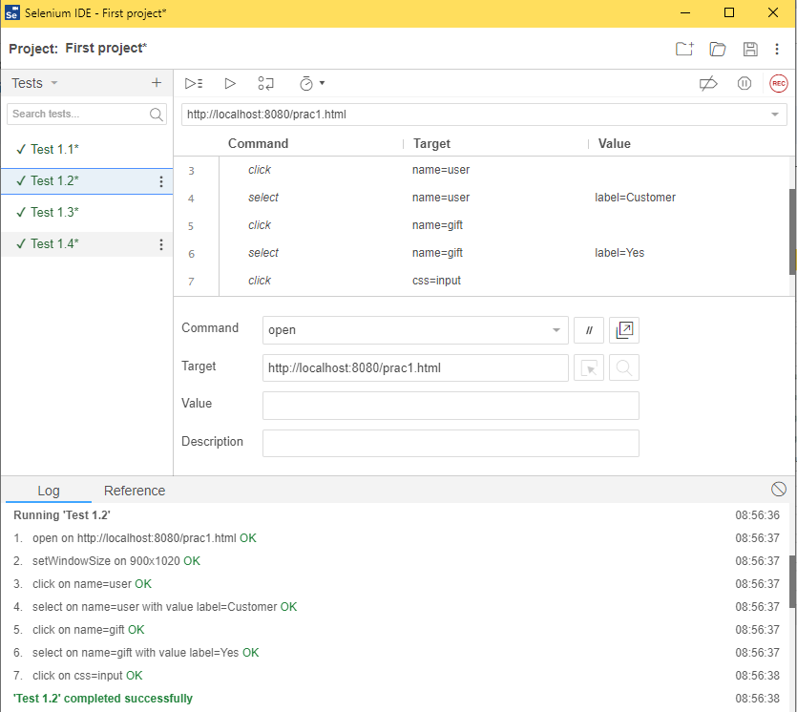

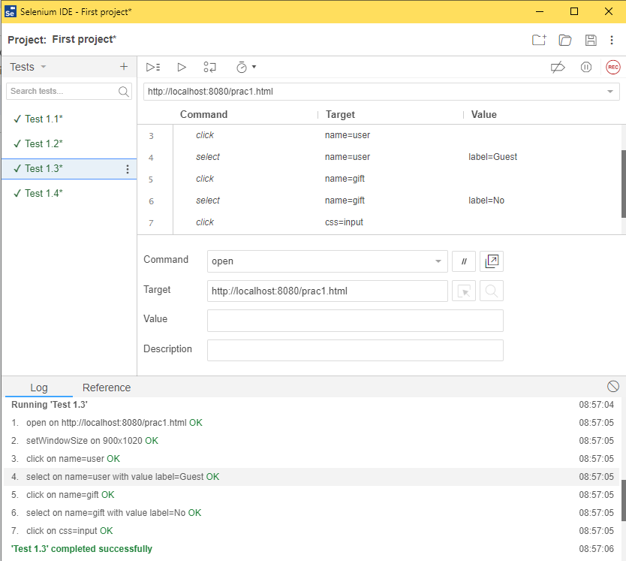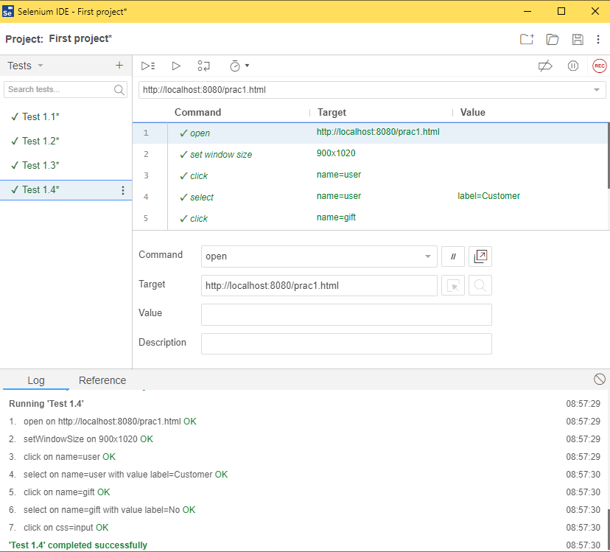

**Q2) Create a HTML code (index.html) and PHP Code (calculator_gcd.php) for GCD (Greatest Common Divisor)**

**HTML Code**

<!DOCTYPE html>

<html>

<head>

<title>GCD Calculator</title>

</head>

<body>

<h1>GCD Calculator</h1>

<form method="post" action="calculate_gcd.php">

<label for="num1">Enter the first number:</label>

<input type="number" name="num1" required><br>

<label for="num2">Enter the second number:</label>

<input type="number" name="num2" required><br>

<input type="submit" value="Calculate GCD">

</form>

</body>

</html>

**PHP Code**

<!DOCTYPE html>

<html>

<head>

<title>GCD Calculator Result</title>

</head>

<body>

<h1>GCD Calculator Result</h1>

<?php

function calculateGCD($a, $b) {

while ($b !== 0) {

$temp = $b;

$b = $a % $b;

$a = $temp;

}

return $a;

}

if (isset($_POST['num1']) && isset($_POST['num2'])) {

$num1 = (int)$_POST['num1'];

$num2 = (int)$_POST['num2'];

$gcd = calculateGCD($num1, $num2);

echo "<p>The GCD of $num1 and $num2 is: $gcd</p>";

} else {

echo "<p>Invalid input. Please enter two numbers.</p>";

}

?>

</body>

</html>

**Use Selenium & Perform 2 test cases**

